FOR IMMEDIATE RELEASE

Stillwater Energy Center’s Reciprocating Engines Earn ACEC Award in Oklahoma
Burns & McDonnell Honored for Planning, Designing Gas-Fired System, a First for the Midwest

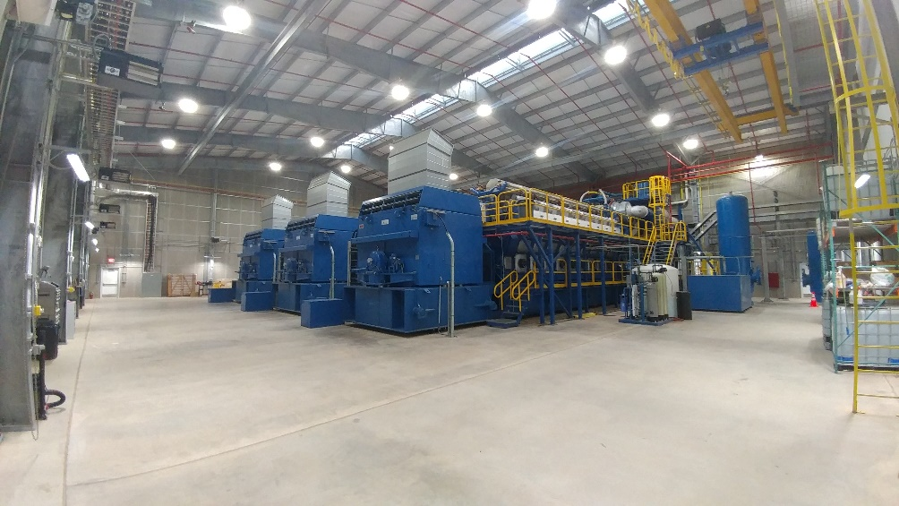
The power generation building at the new Stillwater Energy Center
houses three Finnish-made 18-MW Wärtsilä reciprocating engines.

STILLWATER, Oklahoma (April 6, 2018) — A project to generate rapid, efficient and flexible energy to counterbalance fluctuations in power from renewable sources — a project powered by generation technology that would be the first application of its kind in the Midwest — has been honored as among the year’s best engineering projects in Oklahoma.

The project, known as the Stillwater Energy Center Reciprocating Engine Project, won an Honor Award in the Energy category from the Oklahoma chapter of the American Council of Engineering Companies. The chapter recently presented its 2018 Engineering Excellence Awards.

Judges honored the team led by Burns & McDonnell for developing an innovative approach and delivering it at a fraction of the expected cost. In replacing an aging, city-owned power plant that had come online in the 1950s, the team determined that the Stillwater Electric Utility could get what it needed — an efficient, reliable and flexible way to generate power at times when renewable sources could not keep up with the region’s energy needs — through construction of a new plant to provide low-cost supplemental power.

The Stillwater Energy Center provides 56 megawatts of capacity — more than double the load generating by the old Boomer Lake Station — through the use of three 18-MW Wärtsilä reciprocating engines, each capable of coming online and reaching full load within 10 minutes instead of the minimum four hours required by other systems. This flexibility allows the plant to respond to fluctuations in power from renewable resources such as wind and solar.

The Stillwater Energy Center also is designed to accommodate future expansion, allowing Stillwater Electric Utility, which ranks as the second largest municipal electric utility in Oklahoma, to meet its current needs and take advantage of future opportunities in renewable energy. SEU is the second largest municipal electric utility in Oklahoma. SEU also gave Burns & McDonnell permission to replicate the facility’s design in a plant built to the same specifications in nearby Coffeyville, Kansas, reducing design costs for its municipal owners and bringing low-cost power to more customers in the region.

Other Burns & McDonnell projects winning Engineering Excellence Awards this year from ACEC chapters: Big Canyon Environmental Restoration Project (Honor Award, California), DISA Global Operations Headquarters (Special Achievement Award, Illinois), Integration of RCRA Corrective Action with Facility Demolition for Loveland Products (Merit Award, Nebraska), Union Station Kansas City Westward Expansion (Grand Award, Missouri), and West Blue River Interceptor (Honor Award, Missouri).

###

About Burns & McDonnell
Burns & McDonnell is a family of companies made up of more than 6,000 engineers, architects, construction professionals, scientists, consultants and entrepreneurs with offices across the country and throughout the world. We strive to create amazing success for our clients and amazing careers for our employee-owners. Burns & McDonnell is 100 percent employee-owned and is proud to be on Fortune’s 2018 list of 100 Best Companies to Work For. For more information, visit burnsmcd.com.

